DonateLife Week newsletter articles
The below articles can be used in your internal communications to help raise awareness of organ and tissue donation this DonateLife Week.

Article 1 – It’s DonateLife Week

Most Australians support organ and tissue donation but only one-third have registered – have you?

DonateLife Week (Sunday 26 July to Sunday 2 August) is Australia’s major public awareness week to encourage more Australians to support organ and tissue donation.

We’re excited to be supporting this important week by starting a conversation about the importance of organ and tissue donation.

According to DonateLife, right now thousands of Aussies are waiting for a life-saving transplant. Every year, people die waiting for a transplant.

Getting involved is easy – all you need to do is take one minute to register as an organ and tissue donor at donatelife.gov.au or through Medicare. You could be the reason someone else gets a second chance at life.

Registering as an organ and tissue donor is important because in Australia, your family is always asked to agree to donation. Most families agree when they know you want to be a donor.

Once you’ve registered, tell your family you want to be a donor – someone's life depends on it.

Article 2 – Mia's story

Organ donation saved Mia’s life, twice

DonateLife Week (Sunday 26 July to Sunday 2 August) is Australia’s major public awareness week to encourage more Australians to support organ and tissue donation.

According to DonateLife, right now thousands of Aussies are waiting for a life-saving transplant. Children and young people are amongst those waiting – like Mia, who is now thriving thanks to the generosity of 2 strangers and their families.

Mia was born with liver failure. At just 4 months old she urgently needed a liver transplant to save her life. Thanks to the generosity of a donor family, Mia got the transplant she needed.

But 10 years later, Mia found herself once again needing a liver transplant. She had to give up the activities she loved like dancing, swimming, drama and playing the flute. She missed school and spent less time with her friends.

‘It was so hard to watch Mia’s health get worse before her second transplant,’ said her dad, Michael.

Because of another family agreeing to donation, Mia was able to have a second liver transplant.

Her health improved quickly and within weeks she was back at swimming training. Now at 13 years old, there is no stopping her. Mia has set 3 national and multiple state swimming records in both her age group and the open women’s category.

Mia’s family is forever grateful to her donors and their families. Every year, they celebrate the anniversary of her liver transplants to honour the donors who gave Mia two second chances at life.

It only takes one minute to register as an organ and tissue donor at donatelife.gov.au or through Medicare. Then, tell your family you want to be a donor.

You could be the reason someone like Mia gets a second chance at life.
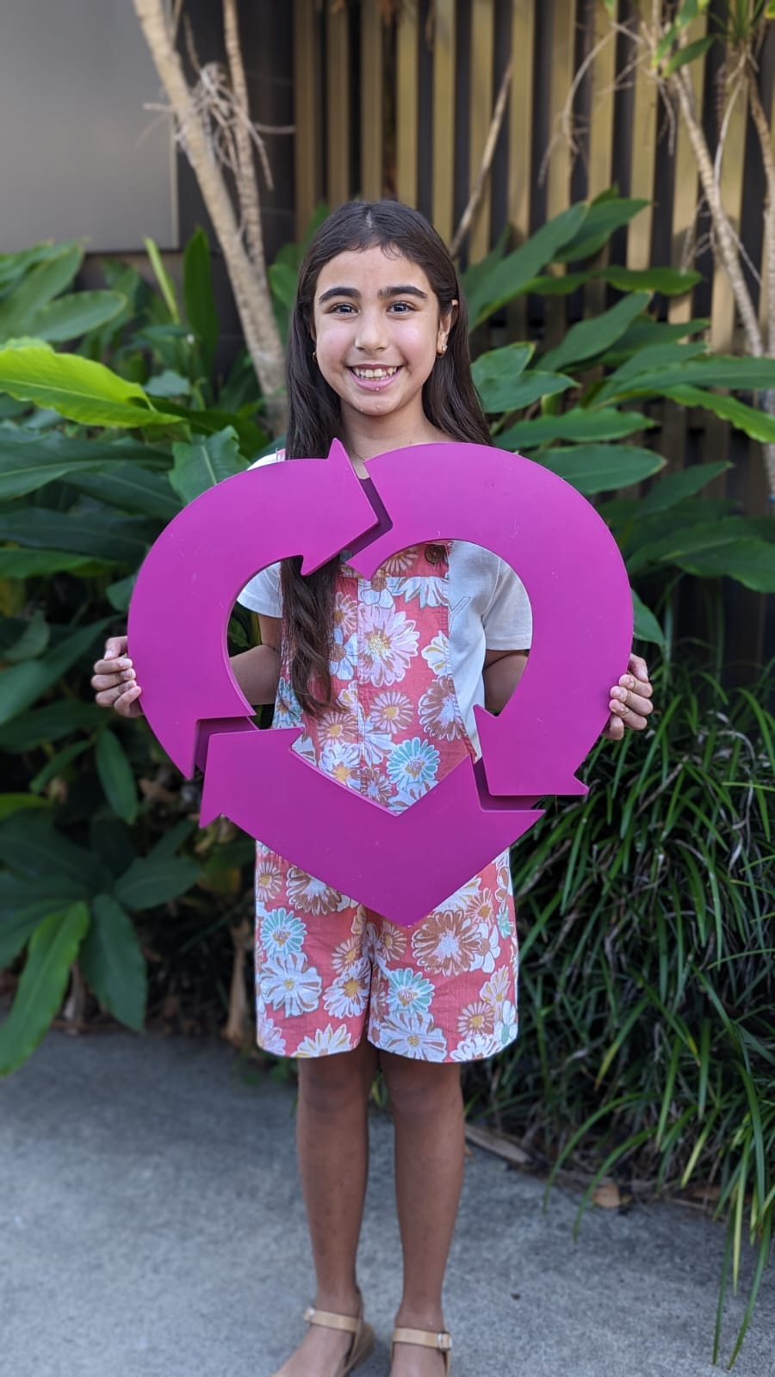
Mia had a liver transplant
Alt text: A child standing outdoors in front of green plants and a wooden fence, holding a large pink heart-shaped symbol with circular arrows, and wearing a floral outfit and sandals.

Article 3 - Aunty Pat's story
Aboriginal and Torres Strait Islander people should be aware that this article contains images and names of people who are now deceased.

A yarn with your mob about organ and tissue donation could save someone’s life
This DonateLife Week (Sunday 26 July to Sunday 2 August), have a yarn with your mob about organ and tissue donation, and be the reason someone else gets a second chance at life.

In Australia, donation will only go ahead with the support of your family. That’s why it’s so important to register as an organ and tissue donor and then let your family know you want to be a donor.

When her brother Ross died from a brain aneurysm, Community Elder Aunty Pat knew Ross wanted to be a donor because he had a yarn with his family well before he died. Through organ donation, he saved the lives of 3 people.

For Aunty Pat, knowing what Ross wanted brought comfort during an incredibly difficult time.

‘Ross would say that it’s better to donate organs to someone than them being in the ground. And, he would say it more than once,’ Aunty Pat said.

‘I’m grateful that he had that written down and we are following his wishes.’

Since then, Aunty Pat has become a passionate advocate for organ donation and volunteers for DonateLife.

‘I guess it’s a way of keeping Ross alive – doing all these things for DonateLife. And I’d really encourage people to sign up to save more lives,’ she said.

It only takes one minute to register as an organ and tissue donor at donatelife.gov.au or through Medicare. Then, tell your family you want to be a donor.
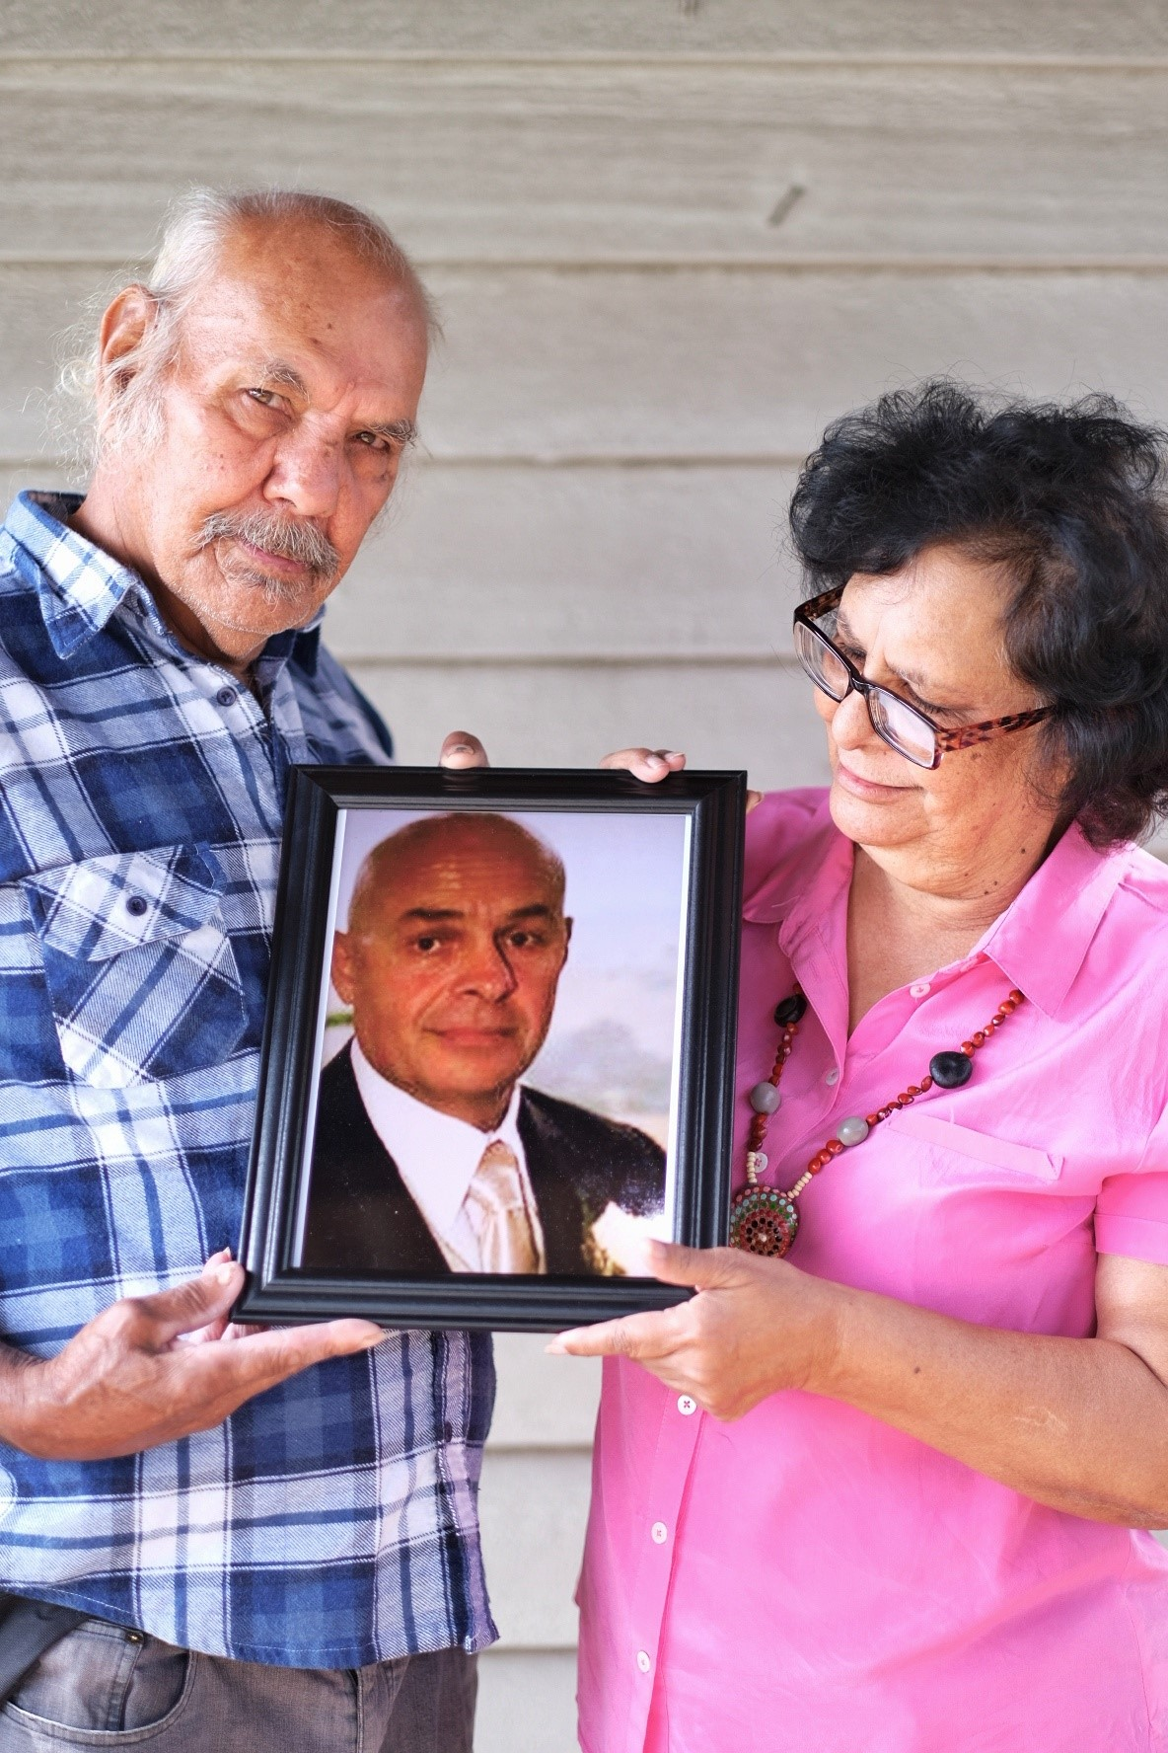
Uncle Billy (left) and Aunty Pat (right) pictured with a photo of their brother Ross who became an organ donor
Alt text: Two people standing against a wooden exterior wall, holding a framed portrait of another person dressed formally; one person is wearing a blue plaid shirt while the other is wearing a pink top, both looking down toward the photograph.

Article 4 – Linda and Laurie’s story
Organ donation saved Laurie’s life, thanks to his perfect match Linda

DonateLife Week (Sunday 26 July to Sunday 2 August) is Australia’s major public awareness week to encourage more Australians to support organ and tissue donation.

According to DonateLife, right now thousands of Aussies are waiting for a life-saving transplant. Like Laurie, many of these Australians need a kidney transplant.

Laurie and his siblings were all born with a rare genetic condition which causes kidney failure. When it became clear Laurie would need a kidney transplant, his wife Linda was determined to help.

It turns out Linda was not just Laurie’s perfect match in love and life. She was also a perfect match to be a living kidney donor for Laurie. In 2021, she donated a kidney and gave Laurie a second chance at life.
‘The immediate difference was just incredible — it was like chalk and cheese. I had been given a second chance at life, and I am going to make the most of it!’ said Laurie.
Since then, life has returned to a joyful and busy rhythm for Linda and Laurie, and their two children. They embrace every opportunity that comes their way including representing Australia at multiple World Transplant Games.
‘It is the most amazing gift you can give someone, but it must be your own decision. I would do it again in a heartbeat if I could,’ Linda said.
But living donation is not an option for everyone. Many people who need a transplant are relying on the generosity of a deceased donor and their family. That’s why Linda and Laurie encourage all Australians to register as organ and tissue donors and then talk to your family about donation.
‘Please take the time to talk with your family about your wishes for the future, especially for those moments when difficult decisions may need to be made. When your loved ones know what you want — or when you know their wishes — it can bring comfort during an incredibly hard time,’ they said.
‘These conversations can also offer peace in knowing that you may help others through the gift of life.’
Registering is quick, easy and takes just one minute at donatelife.gov.au or through Medicare.
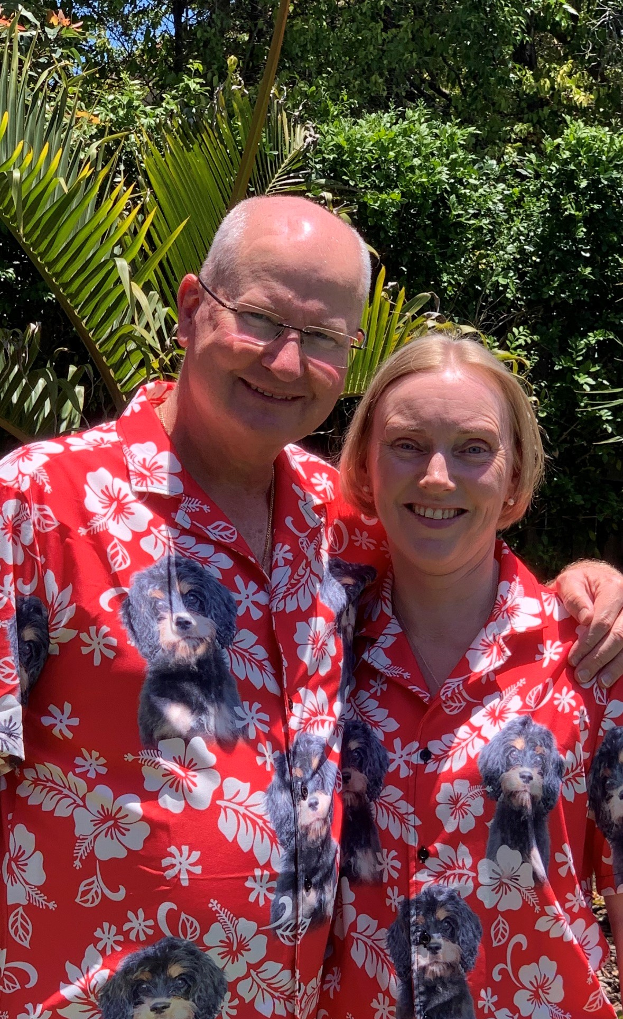
Laurie (left) and Linda (right)
Alt text: Two people standing outdoors in a garden setting, wearing matching red floral shirts with dog prints, posing closely together in bright sunlight with green plants and trees in the background.

